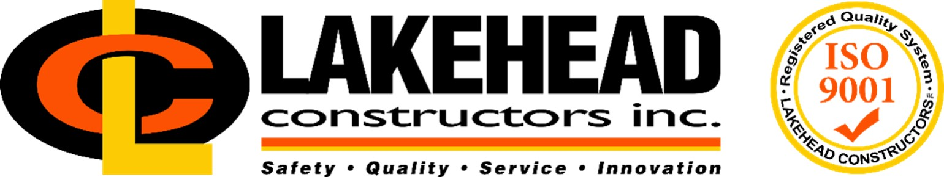

***Posting Date: October 11th, 2024***

# Project Manager/Estimator – Marquette, MI Operations

*Founded in 1916, Lakehead Constructors, Inc. is a leading construction company in the Twin Ports and Iron Range, providing high-quality construction, management and building services to a wide variety of industries in the Upper Midwest region. With one of the most diverse portfolios in the area, Lakehead specializes in industrial construction, including institutional and commercial, mining and steel, oil and gas, power generation and railroad. Founded on a mission of safety, quality, service and innovation, Lakehead employs a highly skilled, flexible workforce with a passion for providing the highest quality service.*

If you enjoy a fast-paced work environment that offers a wide variety of challenging work, and you have a passion for safety, quality, service and innovation, make Lakehead Constructors, Inc. your next career move. With an opportunity to be a part of a highly skilled construction team and the ability to work on a diverse portfolio of projects, Lakehead offers competitive wages and vacation, as well as an excellent benefit package including health, dental, and retirement.

Lakehead Constructors, Inc. is seeking an experienced Project Manager/Estimator to join our team. The position will be focused on industrial construction and maintenance projects in the UP of Michigan. The successful candidate will be responsible for managing and executing all assigned projects while working closely with company leadership in developing new clients and advancing the Company’s market penetration in the region. Achieving success in these initiatives lends the opportunity for career growth and advancement as we continue to develop Lakehead’s newest branch office. In addition to the following general position requirements, the ideal candidate will have 5+ years of experience successfully managing and estimating heavy industrial construction and maintenance, understands union contracts and manages work accordingly, is a self-driven individual who takes initiative and strives for continual improvement, is a personable skilled communicator, and is ready to put forth the efforts required to support successful projects in a complex and dynamic work environment.

## Required skills & responsibilities include, but are not limited to:

* **Project Management**:
  + **Project Execution**
    - Coordinate workflow and effectively communicate project details and status updates to all stakeholders
    - Develop and maintain positive relationships with the engineering / architect team assigned to projects and establish proper flow of communication / documents between parties, including purchase orders, RFI’s, change orders and project meeting minutes
    - Review construction means and methods with Superintendent
    - Communicate effectively with Field Supervision to ensure the use of current plans and specifications, confirm that required materials and equipment are on-site, and ensure compliance with client and company requirements.
    - Manage subcontractors and monitor performance
    - Complete required reports and paperwork in a timely manner utilizing construction ERP software
    - Develop Critical Path Method (CPM) schedule for project or outage. Ensure it is maintained and communicated with appropriate parties.
    - Oversee the preparation and execution of final project punch list for owner’s review
    - Organizes internal and external project close-out meetings and shares lessons learned
    - Demonstrates proficiency in MS office suite (Word, Excel, Outlook, Project, etc.)
  + **Safety & Quality Compliance**
    - Actively uphold and promote Lakehead Constructors’ **Zero Injury Safety Program**, ensuring that all safety protocols and practices are followed at every stage of the project.
    - Collaborate with site leadership to develop and implement site-specific safety plans, continuously monitoring compliance with both regulatory standards and the Zero Injury Program.
    - Conduct regular safety audits, toolbox talks, and job hazard analyses (JHAs) to identify potential risks and mitigate them proactively.
    - Ensure that all employees, subcontractors, and site visitors are trained in safety protocols and understand their role in maintaining a zero-injury work environment.
    - Lead by example, fostering a culture of safety awareness, accountability, and continuous improvement to achieve our goal of zero workplace injuries.
    - Implement QA / QC standards and ensure appropriate ISO 9001 procedures are followed.
* **Financial Oversight**
  + Work with the Estimating department to develop estimates (WinEst / Excel) and bid projects
  + Develop project budget from approved estimate and input to ERP software (Vista Viewpoint)
  + Complete risk assessment and analysis of deviations throughout duration of project
  + Review and approve all project subcontracts, purchases, timesheets and expense reports, and ensure timely completion of A/P unapproved invoices
  + Ensure timely billing of customer invoices and follow up on collections when required
  + Monitor and control project costs and provide status update reports to Sr. Construction Manager
  + Assemble and review final project unit costs to be used for reference for future bids
* **Estimating**:
  + Experience in drawing take-offs and scope document analysis
  + Experience in estimating self-perform work using best practice task quantification and production assignments (e.g. no winging darts)
  + Experience in mechanical processes and flows
  + Experience in proposal submittal and writing
  + Experience in union jurisdiction assignment
* **Customer Relations** 
  + Serve as the primary point of contact for clients, ensuring expectations are met and satisfaction is achieved.
  + Establishes a clear understanding of the reports and information expected by the customer and ensures timely compliance with those expectations is achieved.
  + Communicates customer expectations to project team and provides updates to all when conditions change
  + Follows up with customers upon project completion to verify satisfaction
  + Provide regular project updates and immediately address any critical issues impacting business relations.

## Qualifications:

**Education and/or Experience**

An undergraduate degree in Engineering or Construction Management is preferred, but equivalent field experience will be considered

5+ years of experience managing heavy industrial repairs/projects, understands union contracts and manages work accordingly

A qualified candidate must have a valid driver’s license, as travel to job sites will be required.

**Lakehead Constructors Inc. is an Equal Opportunity Employer. We make reasonable accommodations for individuals with disabilities.**

**If you're ready to join a dynamic and growing team, apply today**

*Pay is commensurate with education and experience*